|  |
| --- |
| Logo, company name  Description automatically generatedAIC, MATHEMATICS LEARNING AREA  **YEAR 11 MATHEMATICS APPLICATIONS – UNIT 2**  **Assessment type: Response**  **TASK 7 – TEST 5** |

Student Name: ____________________ ID: __________ Date: _______

**TIME ALLOWED FOR THIS PAPER**

**Reading and Working time for this paper: 50 minutes in class under test conditions**

**MATERIAL REQUIRED FOR THIS PAPER**

*TO BE PROVIDED BY THE SUPERVISOR*

Question/answer booklet.

*TO BE PROVIDED BY THE CANDIDATE*

*Standard Items:* pens, pencils, pencil sharpener, highlighter, eraser, ruler, drawing templates

**IMPORTANT NOTE TO CANDIDATES**

No other items may be taken into the examination room. It is **your** responsibility to ensure that you do not have any unauthorised notes or other items of a non-personal nature in the examination room. If you have any unauthorised material with you, hand it to the supervisor **before** reading any further.

**Structure of this paper**

|  |  |  |  |  |
| --- | --- | --- | --- | --- |
| Section | Number of questions available | Number of questions to be attempted | Suggested working time (minutes) | Marks available |
| **Calculator Assumed** | **7** | **7** | **50** | **45** |
|  | | | **Marks available:** | 45 |
| **Task Weighting** | 7% |

**Instructions to candidates**

* The rules for the conduct of this examination are detailed in the booklet *WACE* *Examinations Handbook*. Sitting this examination implies that you agree to abide by these rules.
* Answer the questions in the spaces provided.
* Spare answer pages can be used. If you need to use them, indicate in the original answer space where the answer is continued.

### SCSA Content – Topic 2.3 Linear equations and their graphs

**Linear equations**

2.3.1 identify and solve linear equations (with the aid of technology where complicated manipulations are required)

2.3.2 develop a linear formula from a word description and solve the resulting equation

**Straight‐line graphs and their applications**

2.3.3 construct straight-line graphs both with and without the aid of technology

2.3.4 determine the slope and intercepts of a straight-line graph from both its equation and its plot

2.3.5 construct and analyse a straight-line graph to model a given linear relationship; for example, modelling the cost of filling a fuel tank of a car against the number of litres of petrol required.

2.3.6 interpret, in context, the slope and intercept of a straight-line graph used to model and analyse a practical situation

**Simultaneous linear equations and their applications**

2.3.7 solve a pair of simultaneous linear equations graphically or algebraically, using technology when appropriate

2.3.8 solve practical problems that involve determining the point of intersection of two straight-line graphs; for example, determining the break-even point where cost and revenue are represented by linear equations

**Piece‐wise linear graphs and step graphs**

2.3.9 sketch piece-wise linear graphs and step graphs, using technology when appropriate

2.3.10 interpret piece-wise linear and step graphs used to model practical situations; for example, the tax paid as income increases, the change in the level of water in a tank over time when water is drawn off at different intervals and for different periods of time, the charging scheme for sending parcels of different weights through the post

**TO BE AWARDED FULL MARKS ALL WORKING OUT AND CALCULATIONS MUST BE SHOWN**

Question 1 (6 marks)

(a) Solve the equation $4\left(5-2x\right)=x-7$ for $x$. (2 marks)

(b) Write a linear equation for the following and hence determine the number.

A number is chosen and two is added to it. The result is then multiplied by three and five is subtracted. The resultant expression has a value of thirteen. (2 marks)

(c) Ash, Billie and Chris collected a total of $160$ cans to recycle. Ash collected twice as many cans as Chris, Chris collected $12$ more cans than Billie and Billie collected $x$ cans. Determine how many cans Billie collected. (2 marks)

Question 2 (7 marks)

(a) The graph of $y=ax+b$ is shown below. Determine the values of $a$ and $b$. (2 marks)

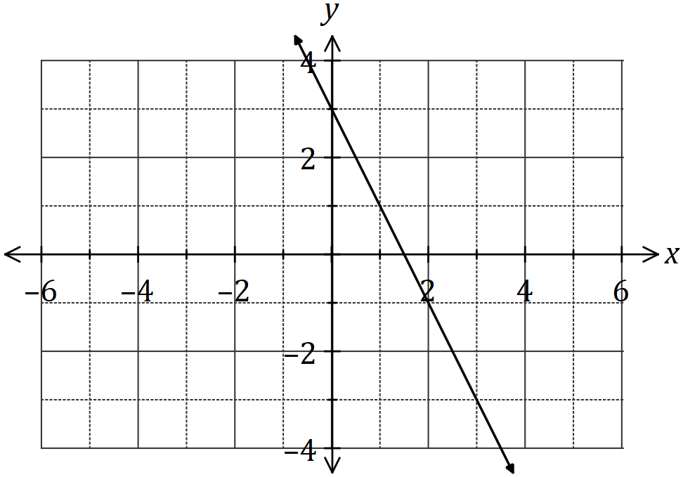

(b) Draw the graph of the line $y=\begin{matrix}1 \\ \overline{2}\end{matrix} x+2$ on the axes below. (3 marks)

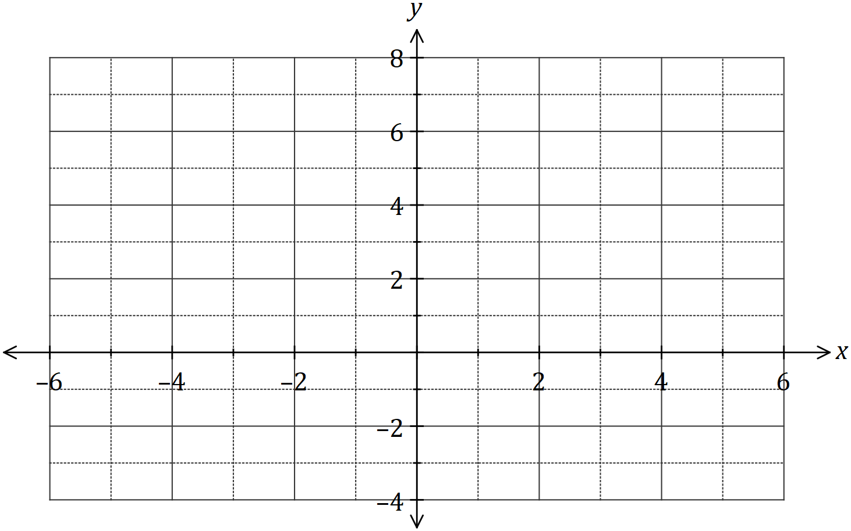

(c) Determine the gradient of the line $3x-2y=12$. (2 marks)

**Question 3 (10 marks)**

Joe’s car sharing company charges a $12.00 flagfall (initial cost for using the service), then a fee of $2.00 per kilometre. Ryan’s car sharing company does not charge a flagfall and charges $3.00 per kilometre. Both car sharing companies’ charges are based on a linear model. Joe’s car sharing company’s linear model is shown on the graph below.

Ryan’s car sharing charges are based on the equation **C = 3k**, where C is the total cost and k is the number of kilometres travelled.

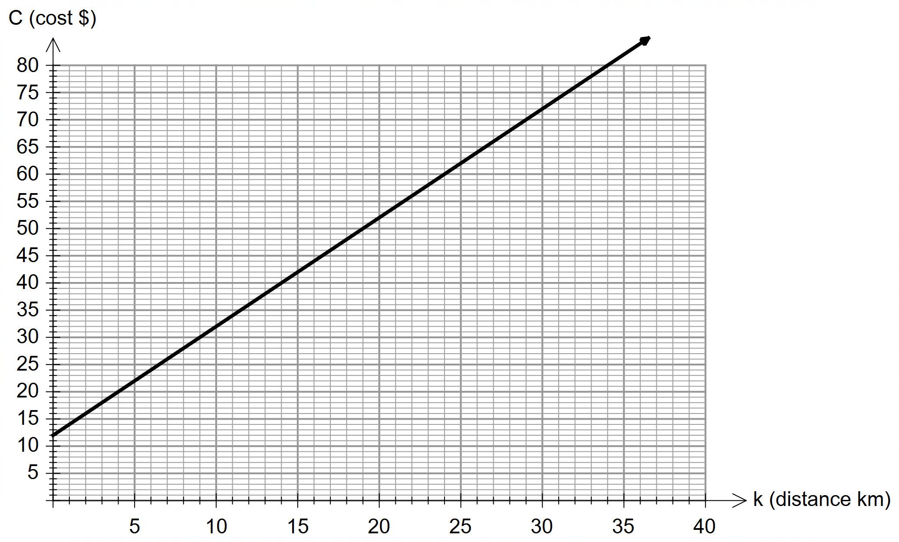

(a) On the axes above, draw the graph for Ryan’s car sharing charges. (2 marks)

(b) Determine the equation for Joe’s car sharing company charges. (2 marks)

(c) Which part of the car sharing cost is described by the gradient of Joe’s equation? (1 mark)

(d) For a ride up to 10 kilometres, determine which is the cheaper company. (1 mark)

(e) Determine the distance when the two companies’ costs are equal. (1 mark)

(f) Determine the maximum distance a person could travel with Ryan’s car sharing company if they only had $87 to spend. (1 mark)

(g) A person travels 27 kilometres with Joe’s car sharing company and is offered a 15% discount on the kilometre part only. Determine the discounted cost of the journey. (2 marks)

Question 4 (6 marks)

(a) Algebraically, solve the simultaneous equations $x+y=7$ and $2y+x=-6$. (2 marks)

(b) It costs $3 for children and $7 for adults to attend a school basketball game. If 5000 people attended the game and the total takings at the door was $25000, determine the number of children and the number of adults that attended the game. (4 marks)

**Question 5 (4 marks)**

(a) Prove that the point (–5, –3) is located on the line with equation 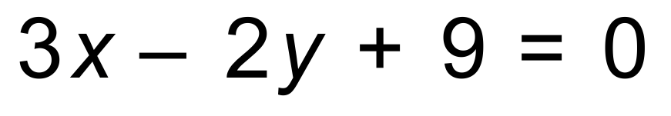.

(2 marks)

(b) The point of intersection (*x, y*) for two lines with equations 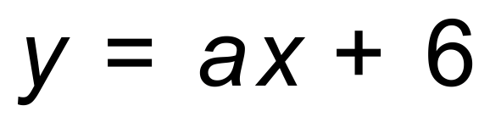 and 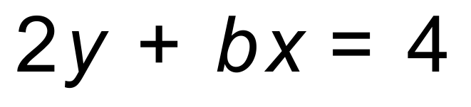

is (–1, 4). Determine the value of *a* and *b*. (2 marks)

**Question 6 (4 marks)**

Plot the following piecewise function on the graph below.

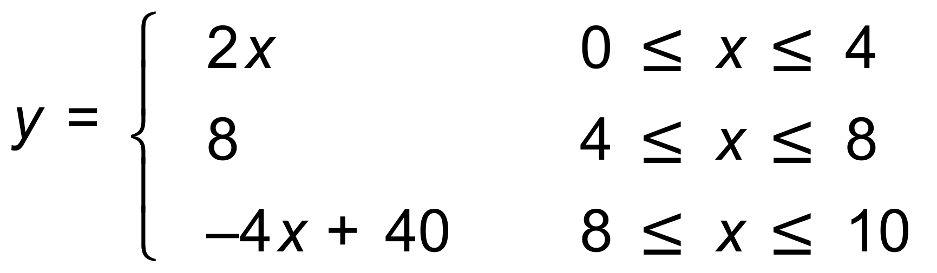

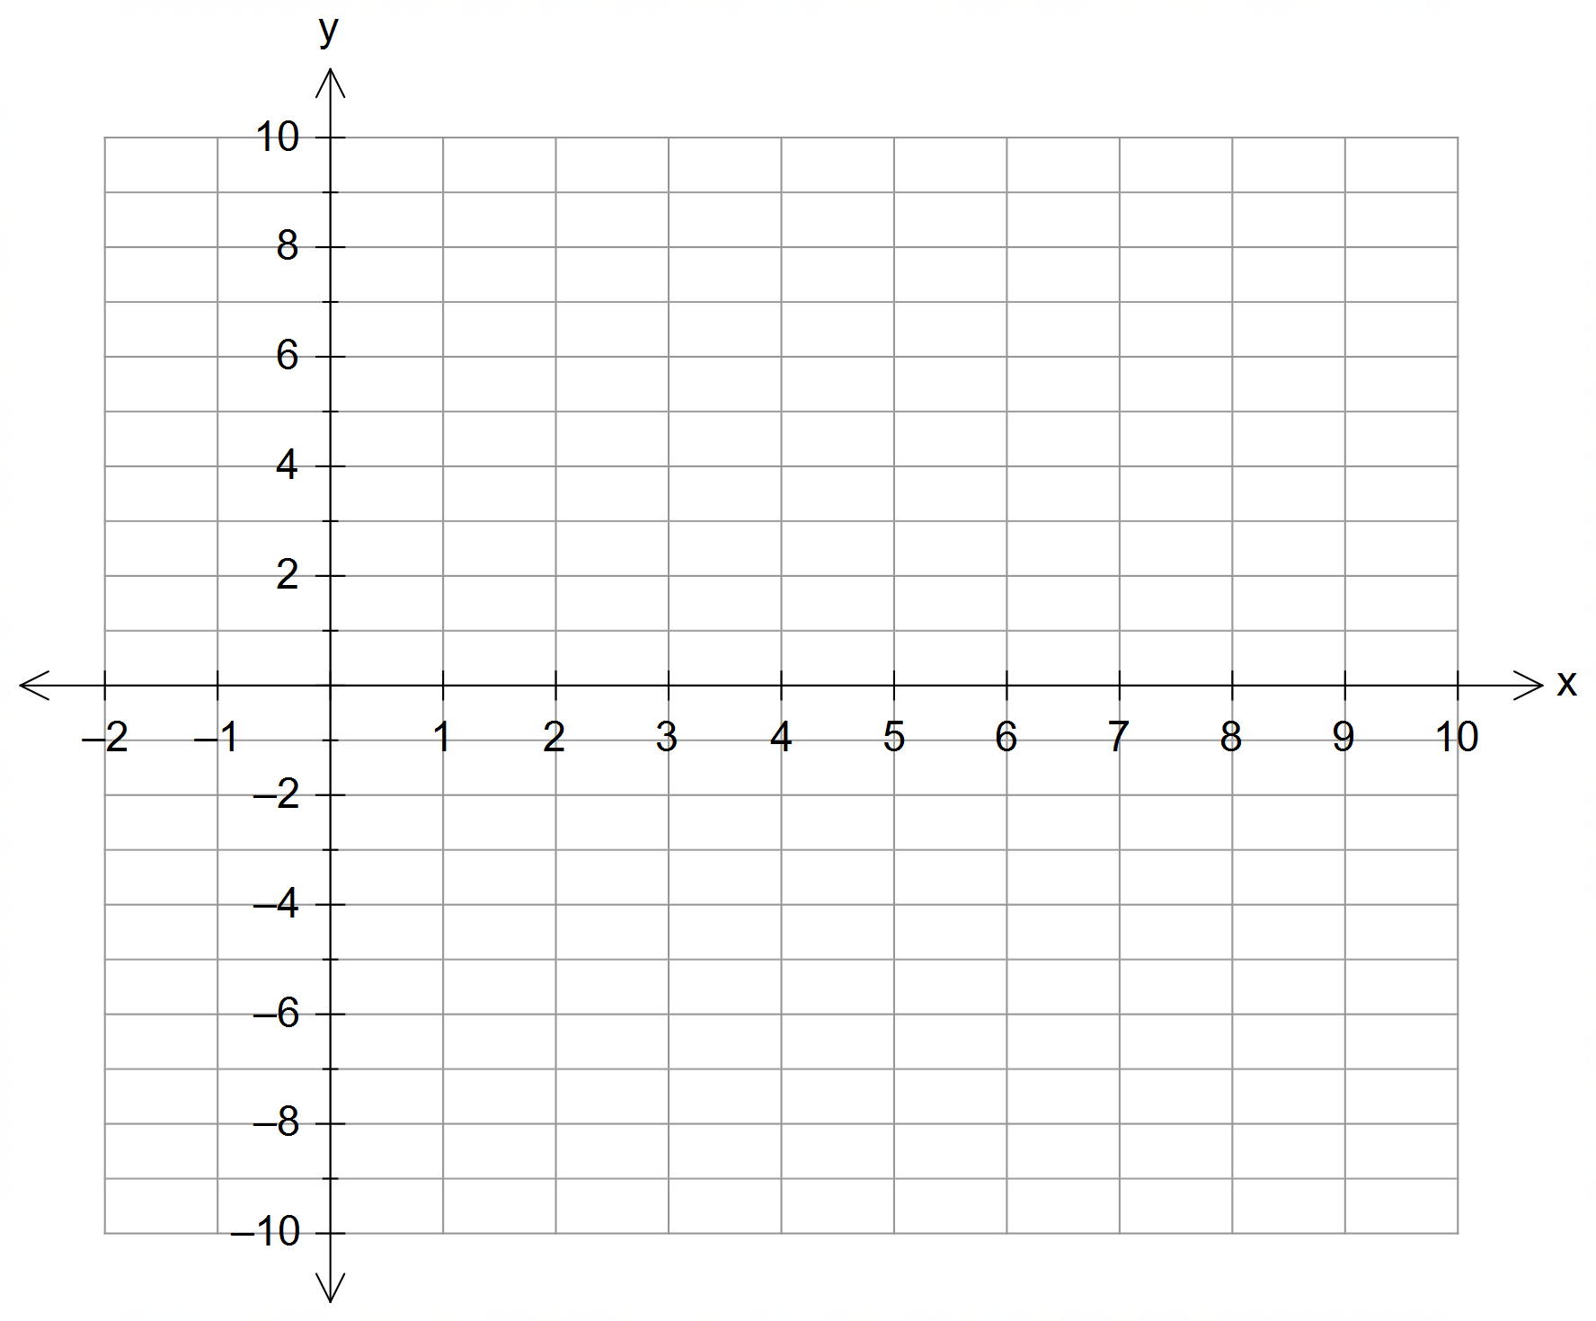

**Question 7 (8 marks)**

John leaves his house at 9.00am and goes for a bike ride. He travels a distance and then undertakes an activity for a period of time. After the activity he travels home.

(a) Based on the information above, match each equation below to the letter attached to each part of the graph. (3 marks)

|  |  |  |  |
| --- | --- | --- | --- |
| **Equation** |  |  |  |
| **Graph** |  |  |  |

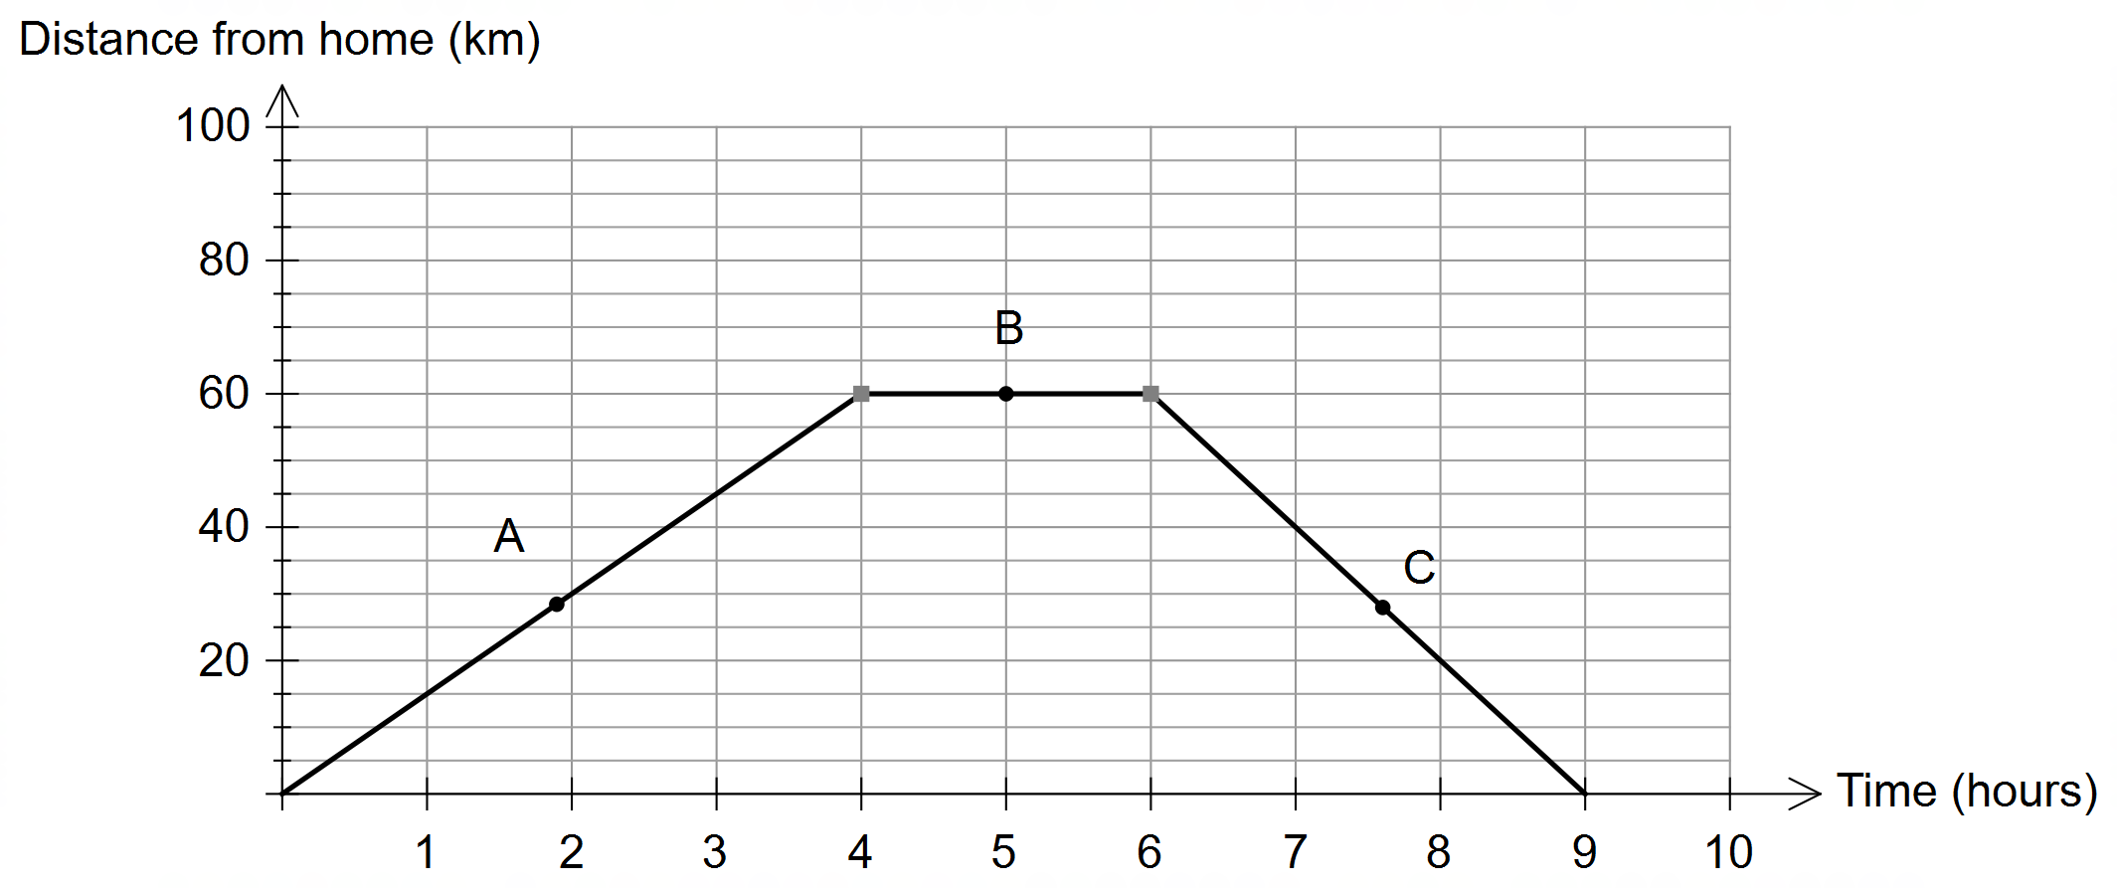

(b) Determine the farthest distance John rode from his home. (1 mark)

(c) At what time of day did John finish his activity? (1 mark)

(d) Calculate John’s fastest speed. (1 mark)

(e) If the graph was not drawn, how would you determine during which part of his journey he rode the fastest? (1 mark)

(f) Calculate the average speed for the complete journey, including stops. (1 mark)